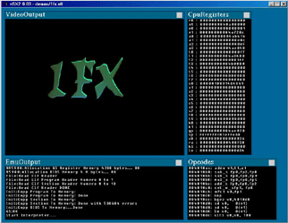
NeutrinoSX2 (nSX2) is an open source emulator for the Play Station 2 platform.
Just as the other emulators of its kind, its still under construction, so yeah it means that you can't run any commercial game with it.
In order to run this emulator at its full speed with all the options turned on, you should have the recommended requirements:
- Intel Pentium 4 2.0 GHz (or AMD XP)
- 512 MB RAM
- 5 MB free disk space (for nsx2)
- 200+ MB free swap space.
- MS DX9 compatible hardware
- MS Windows XP
- Latest DirectX
- Powerful Video Card (Nvidia Geforce or Ati Radeon)

